Black Down & Hindhead Supporters Membership Application
If you would like to help conserve and protect our magnificent local landscapes, please fill in the form below and become a Black Down & Hindhead Supporter of the National Trust.
Your subscription will be spent only on our local National Trust properties.
You don’t need to be a member of the National Trust to become a Supporter.
Mr/Mrs/Miss/Ms ............ First Name …….............................................. Family Name ……………...........................................................
Joint Member: Mr/Mrs/Miss/Ms ............ First Name ............................... Family Name ..........................................................
Address.............................................................................................................................................................................................................
Postcode .................................... Telephone …......................................................... Email …...................................................................

We have no fixed annual subscription but suggest about £25.00 per year for individuals and £35 for joint memberships - for two people over 18 years old living at the same address.
PAYMENT OPTIONS (Standing Order is preferred).
1. By Standing Order (please fill in your bank and payment details below)
To........................................................... Bank plc Account No.......................................................... Sort Code ......... /......... /.........
Please pay to Lloyds Bank plc (30-93-94) for the credit of Black Down & Hindhead Supporters of the National Trust
Account No. 01950670 the sum of £.............. (amount in figures) .................................................................... (amount in words)
now, and continue to pay that amount on the.........................(day) of...............................................(month) every year until
further orders from me in writing, and debit my account accordingly.

2. By direct bank transfer: please use the bank details above and include your name and “Subs” as the reference.
I confirm a bank transfer of my annual subscription of £........................ on date …………………………………………

3. By cheque with a postal application. I enclose a cheque for £………………, made out to Black Down & Hindhead Supporters of the National Trust. Please send to the Membership Secretary, c/o NT Witley Centre – full address below.

----------------------------
Gift Aid I want to Gift Aid my annual subscription and any donation I make in the future or have made in the past 4 years. I am a UK taxpayer and understand that if I pay less Income Tax or Capital Gains Tax than the amount of Gift Aid claimed on all my donations made in that tax year it is my responsibility to pay the difference.
Please notify the charity if you (a) wish to cancel this declaration (b) wish to change your name or home address or (c) no longer pay sufficient income tax and/or capital gains tax.
If you pay Income Tax at the higher or additional rate and want to receive the additional tax relief due to you, you must include all your Gift Aid donations on your Self Assessment tax-return or ask HMRC to adjust your tax code.
----------------------------
All information will be treated as strictly confidential and not shared with any third parties. It will be used only in relation to your Black Down & Hindhead Supporters membership. By signing this Application form, I give consent for BD & HH NT Supporters Committee to use my personal data in order to administer my membership and send me newsletters and information about the local Supporters’ events and fundraising initiatives. See our website for our full privacy policy.
Signed......................................................................................................... Date.........................................
Signature or typed name of the main applicant only (the person who is claiming gift aid)
Please email your completed form to: admin@blackdownhindheadNTsupporters.org
or post to: Membership Secretary, Black Down & Hindhead NT supporters, c/o Witley Centre, Haslemere Road,
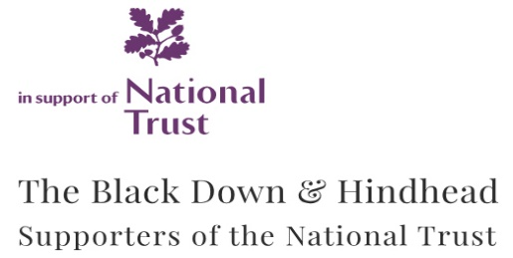
Witley, Surrey, GU8 5QA

Black Down & Hindhead Supporters of the National Trust
Registered Charity No. 205846
www.BlackDownHindheadNTsupporters.org

Revised 11/12/23

